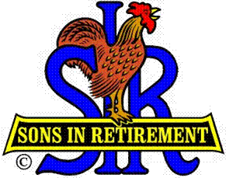
Las Trampas Branch 116
Luncheon Meeting Agenda
February 18, 2019, 11:30 AM

09:30 BEC Meeting
10:30 Social Hour
Greeters – Denny Giambastiani and Don Marini
Raffle – David Ferm, Mike Yale
New Member Orientation – Mike Schneider
11:25 Five Minute Call
11:30 Call to order; Opening Remarks – Big SIR
Pledge of Allegiance – Bill McCord
Chaplain – Lou Sandor
Sunshine Report – Matt Arena
11:37 Story Teller – Pete Coggiola
11:41 Introduce Speaker – John Bettencourt
Guests – Recruitment - Don Schroeder
New Member Induction – Jerry Hicks – Ed Solomon, Jim Seven
Recognize Greeters – Jerry – Denny Giambastiani and Don Marini
Awards – Certificate of Appreciation - Ron Armijo
11:45 Salad Served
RAMP Department Heads Announcements
Don Schroeder - “Bring A Guest”
Activity Coordinator Announcement – Fred Wachowicz
Activity Committee Reports
11:55 Golf Committee Awards and Announcements – Bernie Wroblewski
12:00 Lunch
12:35 Finish Activity Reports
12:40 Intro and Speaker – Speaker Committee – John Bettencourt
Speaker Thank You
13:22 Drawing – Raffle Committee – David Ferm, Mike Yale
Birthday Drawing – Michael Barrington
13:25 Sing Happy Birthday
Sing God Bless America
13:28 Closing Remarks – Thanks; “Bring a Guest”; New Activities & Survey
13:30 Adjourn; Next Meeting, March 18, 2019

